Sprint 4 retrospective

By Gerardo Flores, Ahram Kim – CCP Tour App

# Sprint demo

On this fourth spring, we created ‘map’ tab page which has 2nd floor and 3rd floor information. Each floor has pics and information.

# Definition of done

* Code builds without warnings
* Code unit tested
* All acceptance criteria have been met
  + We start the ‘map’ tab for the user
* Collected data from sponsor, Ashley
* All the automated tests for the user story run without failing
* Build pushed to demo server

# Burndown chart and velocity

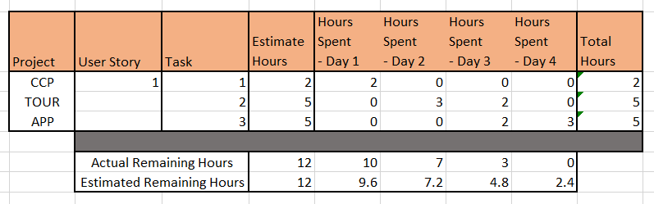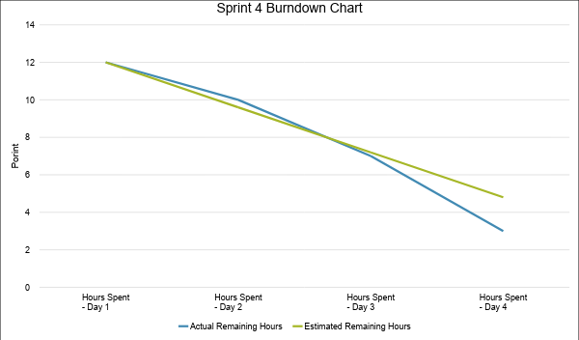

# Project Name: CCP TOUR APP

Team member (print/sign):_____Ahram Kim______________________________________________

Team member (print/sign):_____Gerardo Flores__________________________________________

Sponsor name (printed): Ashley Beasley

**Sponsor signature:** _________________________________________________________________________

Date: 11/05/2018

Sponsor checklist:

* I have seen the user stories completed demoed and they appear to work and meet the DOD
* Team has provided me with a burn down chart and velocity

